LECTURE No. 3 BUSINESS PROCESSES MODELING
List of Topic to be Discuss in this Lecture

- Business Functions
- Business Processes
- Relationship between Business Processes and Business Functions
- Business Processes Modeling Notations
- Case Studies

INTRODUCTION

Understanding business processes and business functions is essential for effectively managing an organization and optimizing its operations. Both terms are interconnected but focus on different aspects of how an organization operates.

BUSINESS FUNCTIONS

A business function refers to a group of related activities or tasks that are specialized and typically handled by a specific department within an organization.

Business functions focus on the specific areas of expertise or responsibility that contribute to the overall success of the organization.

Characteristics of Business Functions:

- Departmental: Business functions are typically confined to a specific department.
- Specialized: Each function has specialized knowledge and skills necessary for executing specific tasks.

- Ongoing: Business functions are continuous and support the ongoing operations of the business.

Major Business Functions:

- Finance and Accounting:
  - Manages financial resources, including budgeting, accounting, and financial reporting.
Example Tasks: Preparing financial statements, managing cash flow, conducting audits, and payroll processing.

Human Resources (HR):
  - Manages employee-related activities such as hiring, training, payroll, benefits, and compliance with labor laws. Example Tasks: Recruitment, performance reviews, employee relations, and benefits management.

Sales and Marketing:
  - Focuses on promoting products or services and generating revenue. Example Tasks: Developing marketing strategies, conducting market research, advertising, managing customer relationships, and closing sales.

Operations/Production:
  - Oversees the production of goods and services, ensuring efficiency and quality. Example Tasks: Managing supply chains, production scheduling, inventory control, and quality assurance.

IT and Technology:
  - Supports the technological needs of the business, managing information systems, infrastructure, and digital solutions. Example Tasks: Maintaining hardware and software, implementing new technologies, cyber security, and supporting business applications.

Examples of Business Functions:

- Sales Function:
  - A sales department is responsible for finding and acquiring customers, selling products or services, and maintaining customer relationships. Example: A sales team contacting potential clients, delivering product presentations, and closing deals.

HR Function:
  - Human resources manage the recruitment and retention of employees, ensuring the organization has the talent it needs. Example: HR managers interviewing candidates, organizing employee training sessions, and conducting performance evaluations.

Finance Function:
  - The finance department handles all financial activities, such as tracking expenses, managing budgets, and generating financial reports. Example: A finance team preparing quarterly financial statements and ensuring tax compliance.

BUSINESS PROCESSES

A business process is a set of activities or tasks designed to achieve a specific organizational goal. These processes are systematic, repeatable, and designed to deliver value to customers, either internal or external. Business processes are often cross-functional, involving multiple departments within an organization.

Characteristics of Business Processes:
- Structured: Business processes are typically well-defined, with clear steps and workflows.
- Repeatable: Processes are designed to be executed repeatedly to ensure consistency.
- Goal-Oriented: The primary purpose of a business process is to accomplish a specific objective.

- Measurable: Business processes are usually monitored and evaluated based on key performance indicators (KPIs).

Core, Support, and Management Business Processes

- Core Processes: Directly deliver the organization’s product or service (e.g., Order-to-Cash).
- Support Processes: Assist core processes without directly contributing to the product (e.g., Procure-to-Pay for raw materials).
- Management Processes: Oversee operations to align with organizational goals (e.g., strategic planning).

Importance of Standardization in Business Processes

- Consistency: Standardized workflows ensure all employees follow the same guidelines, reducing ambiguity and improving task execution. For example, a uniform Procure-to-Pay process streamlines vendor interactions and approval steps.
- Minimizing Errors: Clear, repeatable processes reduce the chances of mistakes. In the Order-to-Cash process, a standardized order entry template ensures accurate data for smoother downstream tasks like shipping and billing.
- Resource Optimization: Standardization eliminates redundancies, allowing for better resource allocation. For example, a Recruit-to-Retire HR process prevents overlap in onboarding and training, saving time and effort.
- Outcome: Standardization leads to more efficient workflows, better coordination between departments, reduced costs, and higher organizational performance.

Examples of Business Processes:

- Order-to-Cash Process (Core Process):
  - This process encompasses all activities from receiving a customer order to receiving payment.
Steps include: Order entry, order fulfillment, shipping, invoicing, and payment collection.
Example: An e-commerce company receives a customer order, processes it, ships the product, generates an invoice, and collects payment.

Procure-to-Pay Process (Support Process):
  - This involves the process of acquiring goods or services, from requesting a purchase to making a payment to the supplier. Steps include: Purchase requisition, vendor selection, purchase order creation, goods receipt, and payment.

Example: A manufacturing company purchasing raw materials, from requisitioning materials to paying suppliers.

Recruit-to-Retire Process (Support Process):

  - This process covers the entire employee lifecycle, from recruitment to retirement. Steps include: Recruitment, onboarding, performance management, training, and retirement or exit management.

Example: A company's HR team hires an employee, manages their career progression, and facilitates their retirement.

Importance of Business Processes:

  - Efficiency: Well-defined processes help streamline operations and reduce inefficiencies.
  - Quality Control: Standardizing processes ensures consistency and high quality.
  - Customer Satisfaction: Efficient processes lead to timely delivery and higher customer satisfaction.
  - Scalability: Businesses can grow by replicating efficient processes across departments or regions.

RELATIONSHIP BETWEEN BUSINESS FUNCTIONS AND BUSINESS PROCESSES:

  - Business Functions Support Business Processes:
Each business function plays a role in completing a business process. For example, the HR function manages the recruit-to-retire process, and the finance function supports the procure-to-pay process.

Cross-Functional Collaboration:
Business processes often span multiple functions. For example, the order-to-cash process involves the sales, finance, and logistics functions working together to fulfill an order and collect payment.

Examples of Business Processes Involving Multiple Functions:

- Order Fulfillment Process (Cross-Functional):

  - Departments Involved: Sales, finance, warehouse, and logistics. Steps: The sales team enters an order, the finance team processes payment, and the warehouse and logistics teams fulfill and ship the product.

Product Development Process (Cross-Functional):
  - Departments Involved: Research and development (R&D), marketing, and operations.
Steps: The R&D department designs a new product, the marketing team researches customer needs, and the operations team handles the production process.

SUMMARY:

- Business processes are the workflows that organizations follow to achieve specific objectives, often involving multiple departments.
- Business functions are the specialized departments or areas within an organization responsible for specific tasks that support these processes.
- Business processes often involve the collaboration of multiple functions to deliver value to customers and meet organizational goals.
- Effective business processes and well-managed business functions lead to greater organizational efficiency, improved product and service quality, and increased customer satisfaction.

Business Process Modeling Notation (BPMN 2.0)

For every type of process, there is a flowchart. For business, there’s even an entire process flowchart language. It’s called Business Process Model and Notation, or simply, BPMN 2.0.

Common BPMN Symbols
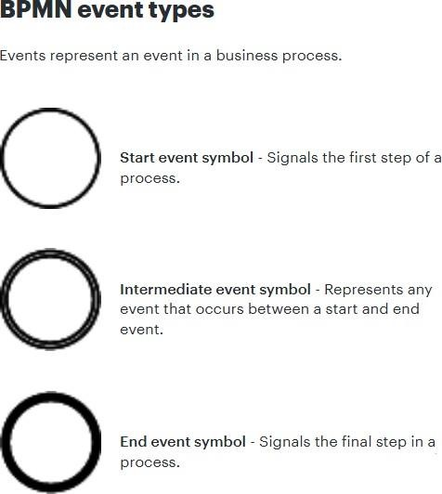

BPMN event Symbols
Each of these BPMN event symbols can be styled to represent the specific details of their process. The examples below are contained within start event symbols, but they can be combined with any event type. Common event symbols represent the following circumstances:
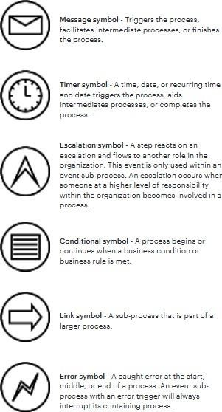

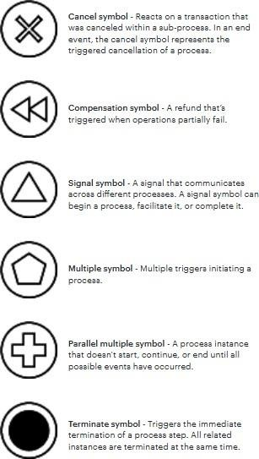

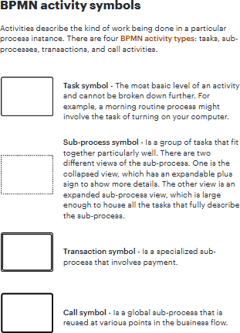

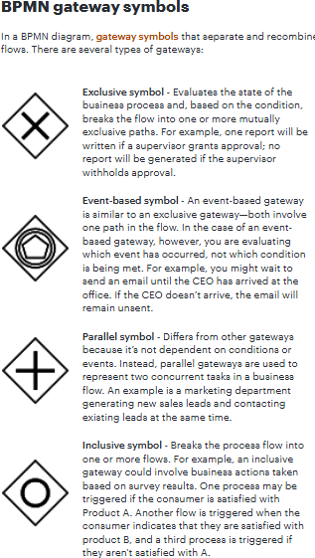

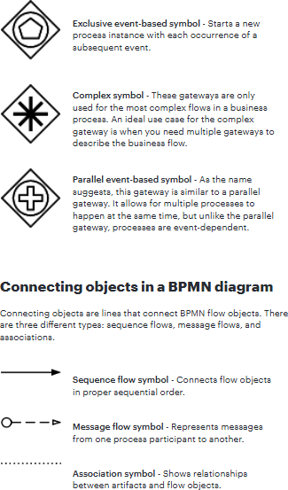

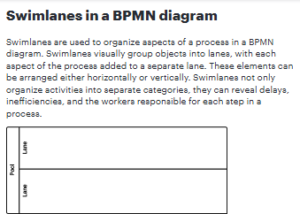

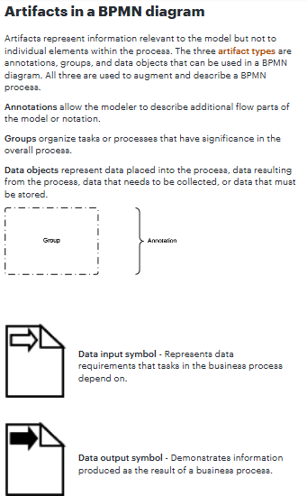

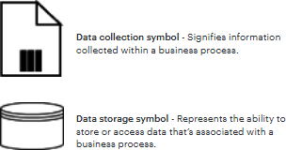

Case Study 1: You’re Yoga Process
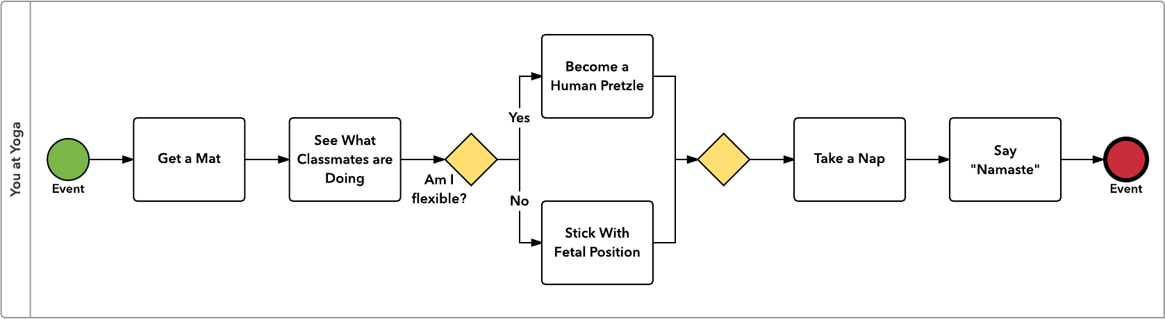
Case Study 2: Leave Request to HR Process
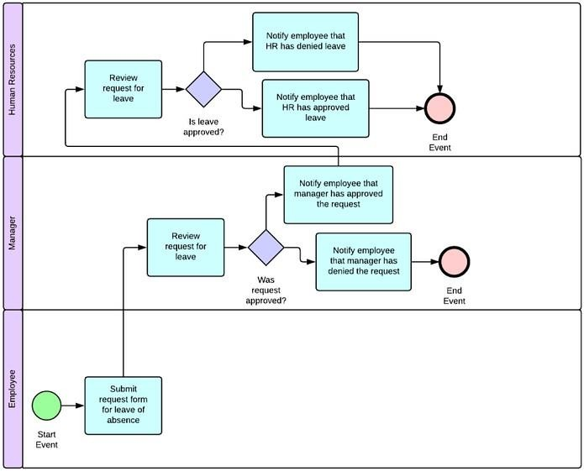

Case Study 3: Order Management Process
